PROJECT :

STUDENT REGISTRATION SYSTEM

MS Access with VBA

Tools used : MS Access

1. Home Page – Registration Form



**Student Registration Form in MS Access**

**1. Planning Your Database**

* **Student Details Table:** Will hold core student information.
* **Gender Table:** Will hold distinct gender options.
* **Courses Table:** Will hold distinct course options.

**2. Creating the Tables**

**2.1. Creating the Gender Table**

***Gender Table***

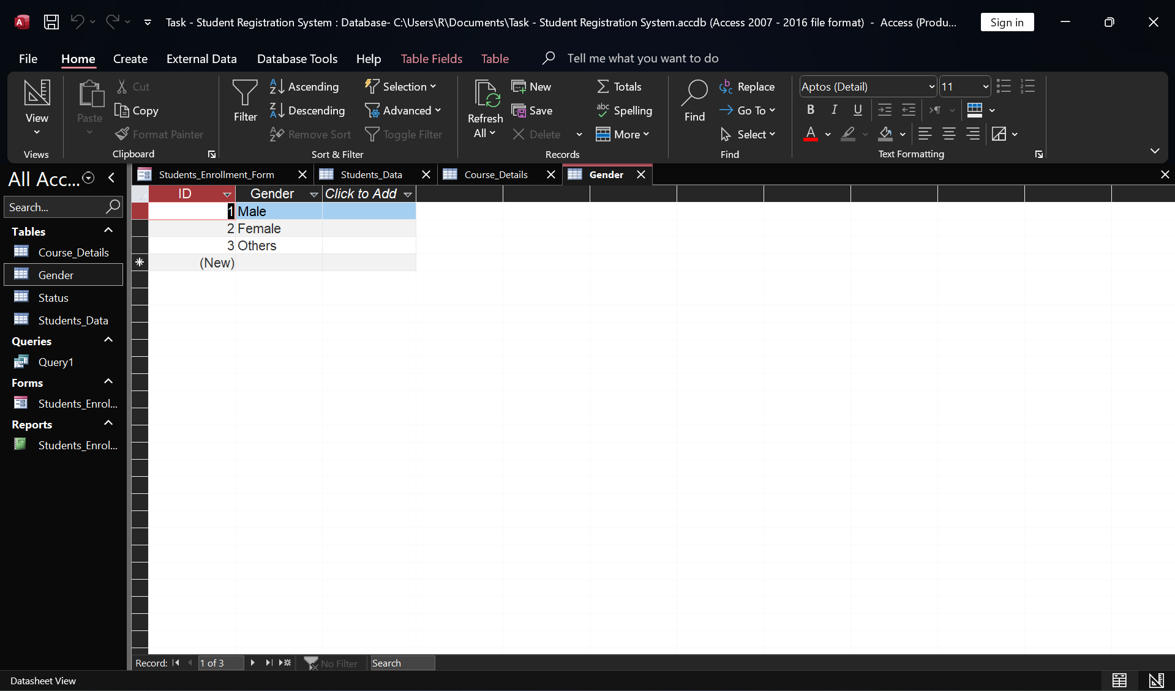

1. Open MS Access and create a new blank desktop database. Save it with a suitable name (e.g., StudentRegistrationForm.accdb).
2. In the "Create" tab, click on "Table Design."
3. Add the following fields:
   * **Field Name:** GenderID
     + **Data Type:** AutoNumber (Primary Key)
   * **Field Name:** Gender
     + **Data Type:** Short Text
4. Save the table as Gender.
5. Switch to Datasheet View and enter a few gender options (e.g., "Male," "Female," "Other").

**2.2. Creating the Courses Table**

**Course Details Table**

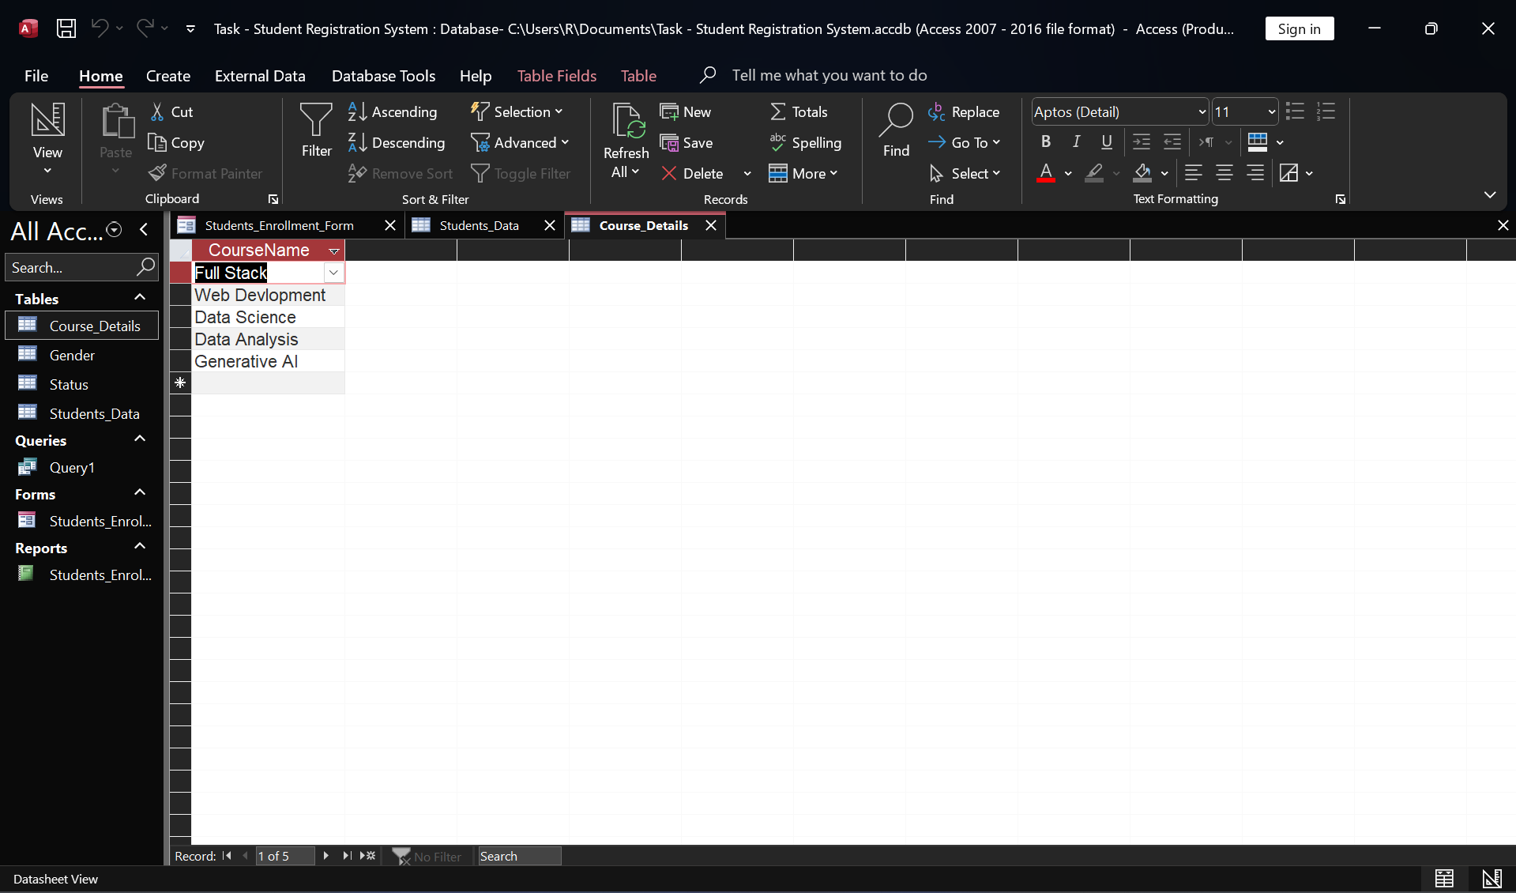

1. In the "Create" tab, click on "Table Design."
2. Add the following fields:
   * **Field Name:** CourseID
     + **Data Type:** AutoNumber (Primary Key)
   * **Field Name:** CourseName
     + **Data Type:** Short Text
3. Save the table as Courses.
4. Switch to Datasheet View and enter a few course options (e.g., "Web Development," "Full Stack", "Data Analysis", ”Data Science”, “Generative AI”).

**2.3. Creating the Student Details Table**

**Database**

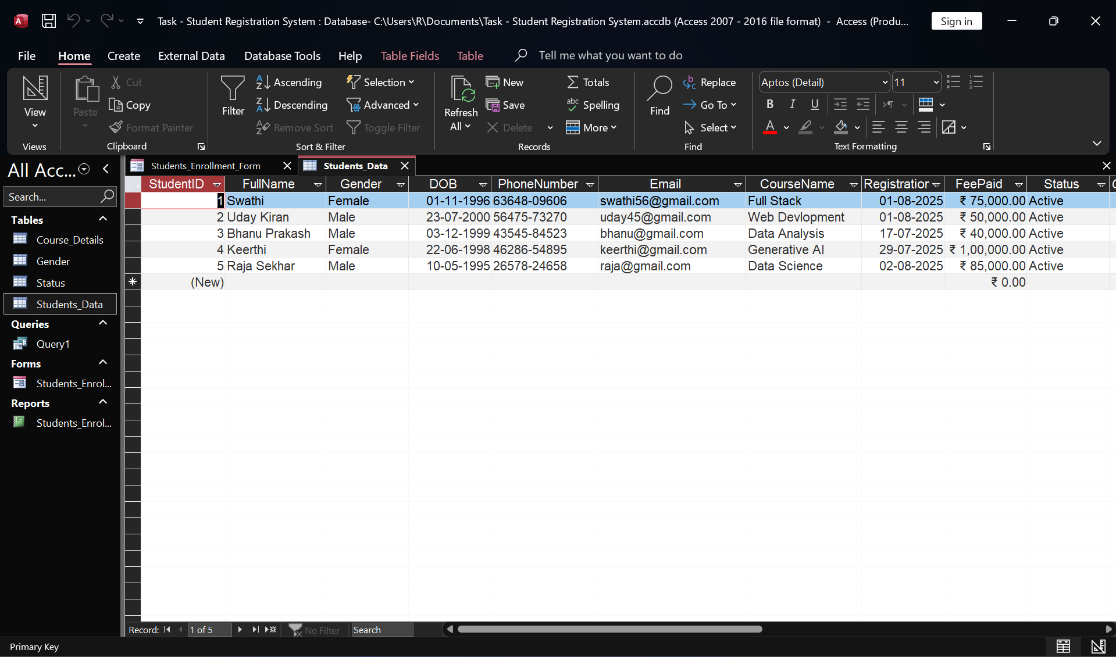

1. In the "Create" tab, click on "Table Design."
2. Add the following fields:
   * **Field Name:** StudentID
     + **Data Type:** AutoNumber (Primary Key)
   * **Field Name:** FirstName
     + **Data Type:** Short Text
   * **Field Name:** LastName
     + **Data Type:** Short Text
   * **Field Name:** DateOfBirth
     + **Data Type:** Date/Time
   * **Field Name:** GenderID_FK
     + **Data Type:** Number (Long Integer) - This will be our foreign key to tblGender.
   * **Field Name:** CourseID_FK
     + **Data Type:** Number (Long Integer) - This will be our foreign key to tblCourses.
   * **Field Name:** Email
     + **Data Type:** Short Text
   * **Field Name:** PhoneNumber
     + **Data Type:** Short Text
   * **Field Name:** FeePaid
     + **Data Type:** Number
   * **Field Name:** Status
     + **Data Type:** Short Text
3. Save the table as tblStudentDetails.

**Status Table**

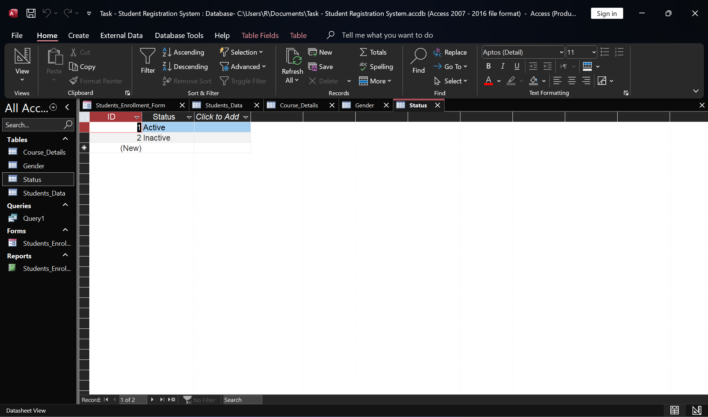

**3. Establishing Relationships**

1. Go to the "Database Tools" tab and click on "Relationships."
2. The "Show Table" dialog box will appear. Add Table Student_Details, Table Gender, and Table Courses. Close the dialog box.
3. Drag the GenderID field from Table Gender to the GenderID_FK field in Table Student_Details.
4. In the "Edit Relationships" dialog box, check "Enforce Referential Integrity." Click "Create."
5. Drag the CourseID field from Table Courses to the CourseID_FK field in Table Student_Details.
6. In the "Edit Relationships" dialog box, check "Enforce Referential Integrity." Click "Create."
7. Close the Relationships window and save the changes.

**4. Creating the Student Registration Form**

1. In the "Create" tab, click on "Form Wizard."
2. In the Form Wizard:
   * Select Table: Table Student_Details from the "Tables/Queries" dropdown.
   * Move all available fields (StudentID, FirstName, LastName, DateOfBirth, GenderID_FK, CourseID_FK, Email, PhoneNumber, Fee Paid, Status) to the "Selected Fields" list using the >> button.
   * Click "Next."
   * For the layout, choose "Columnar." Click "Next."
   * Give your form a title (e.g., Student Registration Form). Click "Finish."
3. The form will open in Form View. Now, let's switch to Design View to refine it.
   * Right-click on the form tab and select "Design View."

**4.1. Converting Foreign Key Fields to Combo Boxes**

To make data entry easier and prevent errors, we'll use combo boxes for GenderID_FK and CourseID_FK.

**For Gender:**

1. Delete the existing GenderID_FK text box control on the form.
2. In the "Design" tab, click on "Combo Box" from the "Controls" group.
3. Draw a combo box on the form where the GenderID_FK field was.
4. The "Combo Box Wizard" will appear:
   * Select "I want the combo box to look up the values in a table or query." Click "Next."
   * Select Table: Gender. Click "Next."
   * Move GenderID and Gender to the "Selected Fields" list. Click "Next."
   * Adjust column width if needed. Click "Next."
   * Check "Store that value in this field:" and select GenderID_FK. Click "Next."
   * Enter a label for your combo box (e.g., Gender). Click "Finish."

**For Courses:**

1. Delete the existing CourseID_FK text box control on the form.
2. In the "Design" tab, click on "Combo Box" from the "Controls" group.
3. Draw a combo box on the form where the CourseID_FK field was.
4. The "Combo Box Wizard" will appear:
   * Select "I want the combo box to look up the values in a table or query." Click "Next."
   * Select Table: Courses. Click "Next."
   * Move CourseID and CourseName to the "Selected Fields" list. Click "Next."
   * Adjust column width if needed. Click "Next."
   * Check "Store that value in this field:" and select CourseID_FK. Click "Next."
   * Enter a label for your combo box (e.g., Course). Click "Finish."

**4.2. Arranging and Formatting Controls**

* Drag and resize controls to make your form visually appealing and easy to use.
* Add a title to the form using a "Label" control from the "Controls" group (e.g., "Student Registration Form").
* You can change font styles, colors, and background using the "Property Sheet" (if not visible, press Alt + Enter).

**5. Adding "Save" and "New" Buttons**

1. In "Design View" of Student Registration Form, go to the "Design" tab.
2. Click on the "Button" control from the "Controls" group.
3. Draw a button on your form. The "Command Button Wizard" will appear.

**5.1. Adding the "Save" Button**

1. In the "Categories" list, select "Record Operations."
2. In the "Actions" list, select "Save Record." Click "Next."
3. You can choose to display "Text" (e.g., "Save") or a "Picture" for your button. Select "Text" and type "Save Record." Click "Next."
4. Give the button a meaningful name (e.g., SaveRecord). Click "Finish."

**5.2. Adding the "New" Button**

1. In "Design View," click on the "Button" control again.
2. Draw another button on your form.
3. The "Command Button Wizard" will appear.
4. In the "Categories" list, select "Record Operations."
5. In the "Actions" list, select "Add New Record." Click "Next."
6. You can choose to display "Text" (e.g., "New") or a "Picture" for your button. Select "Text" and type "New Record." Click "Next."
7. Give the button a meaningful name (e.g., NewRecord). Click "Finish."

5.3 Test the buttons

Switch to "Form View" and try entering some data, then click "Save Record." Click "New Record" to clear the form for new entry.

1. **Creating a Student Report**

**Report**

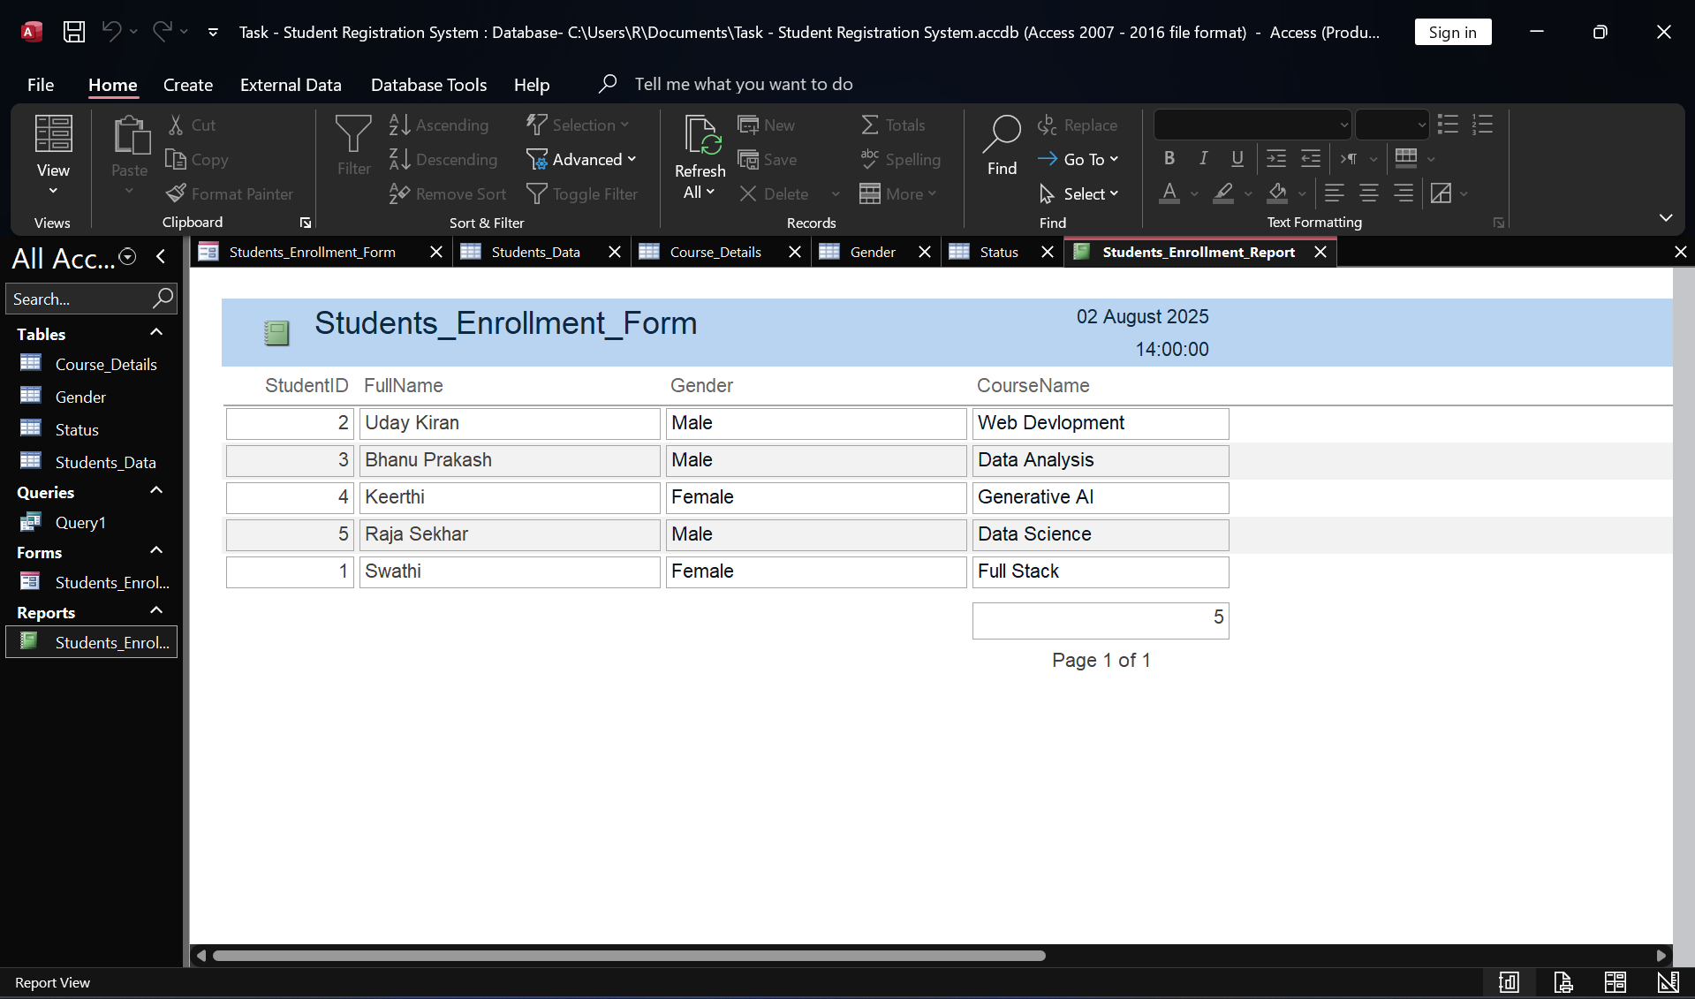

A report allows you to view and print your student data in a structured format.

1. In the "Create" tab, click on "Report Wizard."
2. In the Report Wizard:
   * From the "Tables/Queries" dropdown, select Table: StudentDetails.
   * Move all available fields (StudentID, FirstName, LastName, DateOfBirth, GenderID_FK, CourseID_FK, Email, PhoneNumber, Fee Paid, Status) to the "Selected Fields" list.
   * **Important:** To display the actual Gender and Course Names instead of their IDs, we need to base our report on a query that joins the tables. For simplicity in this documentation, we'll proceed directly with Table Student_Details.
     + **Advanced Tip:** To include Gender and Course names, you would first create a Query (under Create -> Query Design) that joins StudentDetails, Gender, and Courses. Then, you would select this query as your data source for the report wizard.
   * Click "Next."
   * You can add grouping levels if desired (e.g., by Course). Click "Next."
   * You can choose sorting options (e.g., by LastName, then FirstName). Click "Next."
   * Choose a layout (e.g., "Tabular") and orientation (e.g., "Portrait"). Click "Next."
   * Give your report a title (e.g., Student List). Click "Finish."
3. The report will open in Print Preview. You can switch to "Design View" to customize its appearance, add headers/footers, logos, etc.